DWP Support for Schools Summer 2022
what is a support for schools advisor?
We provide a free, impartial, flexible service, supporting Schools & Colleges with their careers programme and helping meet the Gatsby Benchmarks
who are we?
Our advisors are:
Sunderland/South Tyneside – elaine.bell3@dwp.gov.uk
Northumberland – claire.angus@dwp.gov.uk
North Tyneside – melissa.laverick@dwp.gov.uk
Gateshead/Newcastle – stephen.tough1@dwp.gov.uk
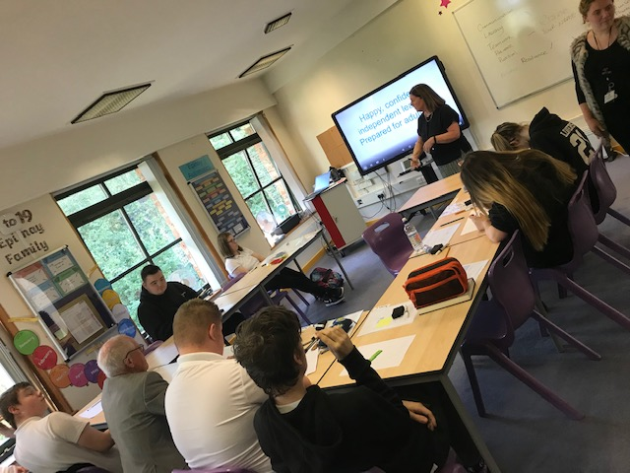

Reflections of 2022

Important Dates 22/23
impot date
Results Day (A Level) – 18 Aug 2022
Results Day (GCSE) – 25 Aug 2022
Green Careers Week: 7-12 Nov 2022
National Apprenticeship Week: 6-12 Feb 2023
Careers Week: 6-11 March 2023

Our Services
Workshops

CV skills Employability skills
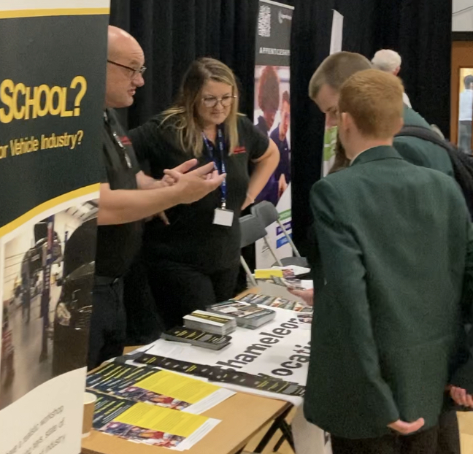
Careers Fairs

Mock Interviews
And many more ….

This academic year has been one of change as we all began to return to business as usual. Our team has strengthened and continued to evolve, we welcomed back Melissa from secondment and two new team members Claire and Stephen. We have already seen a sharp increase for bespoke face-to-face engagement from Schools across the Region but can now flex diaries to accommodate additional requests. The team are particularly keen to support Careers Leaders about what we offer and would be delighted to deliver sessions supporting the Careers Agenda within schools. both face to face and virtually. This fully supports schools with their Careers Agenda and importantly all sessions fully support and underpin the Gatsby Benchmarks for schools at no cost.

Our Successes
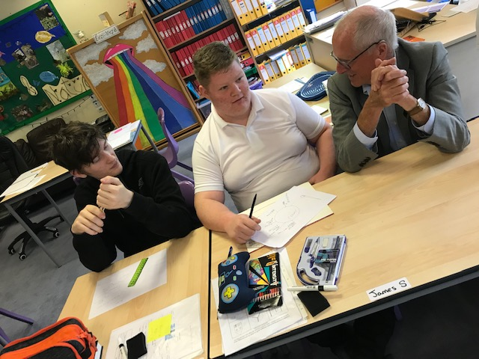

IMPORTANT MESSAGES

We are flexible and available throughout school holidays.
We can support and help with Planning, Results days, Careers Weeks, Access to Apprenticeships, Work Experience and much more
Please just get in touch via e/mail.

In collaboration with Epinay School in South Tyneside, we hosted Sir John Holman, (Gatsby Benchmarks creator). Sir John met pupils and was keen to answer questions, one of which was ‘how do you become a Sir?’ We received excellent feedback from him after the event:
Dear Elaine
I very much enjoyed seeing you teach at Epinay on Thursday. What great engagement you got from the students! Tomorrow I’m giving a talk at the Talentino conference, about Careers guidance for students with SEND. I thought I would mention Epinay and your work, because I was impressed with what I saw when I visited.
We supported Gateshead IAG team delivering their SEND Careers Event hosted by Dryden school, it was a tremendous day which schools have now requested become an annual event.
Our own team was able to help support two work experience placements within our local Jobcentres.
Feedback
I have just given out your feedback forms from the mock interviews on Tuesday, the students were so pleased with it all and you could literally see their confidence rising. Your engagement with them has had, and will continue to have, a massive effect on their lives. So, for that we massively thank you. Biddick Academy
I just wanted to thank you again for attending our year 10 careers day yesterday. We really appreciate your support with our careers programme and the students found your sessions really useful. See you in the new academic year. Kind regards, Prudhoe Community High School
The Careers team at Excelsior Academy would like to formally thank you for your time, energy and support at our Careers Fair on Friday last week. We were so pleased to be running such a large-scale event after the last few years, and we wouldn't have been able to do this without you all. Thank you so much. The students really got a lot from it and there have already been some excellent conversations and a real focus and enthusiasm for talking about careers. Thank you again Excelsior Academy
Can I thank you all for your hard work, support and participation in Wednesday’s Careers Event The event was a success and feedback from young people, parents and teachers was that the event was effective in supporting young people to think about their aspirations, the steps required to get there and the support that is available and on hand. We see an event of this nature as being really important in supporting young people with SEND and their parents/carers to make informed decisions about their future and allay any anxieties they feel regards to this. Lee Peacock IAG Gateshead Team Manager

